Bcs 54

*Overflow
- Jab kisi calculation ka result computer ki maximum limit se bada ho jata hai, tab overflow hota hai.
- Example (Multiplication Se Overflow)

*Underflow
- Jab kisi calculation ka result computer ki minimum limit se chota ho jata hai, tab underflow hota hai.

*Inverse interpolation
Function ke output se uska input nikalna

*Accuracy
Aapka measurement kitna correct h asli value k mukable
Ex. thermometer

*Precision
Aapka measurement kitna close h dusre element se
Ex. weight

*Significant digits, figures
Number ki precision dikhata h leading aur trailing zeroes ko chod kar
Ex. 0.00456 me significant digits 4,5,6 h
Total significant digits 3 h starting k zeroes count nhi hote

*Interpolation
- do known values ke beech mein nayi value nikalna.

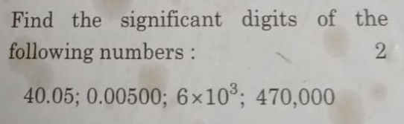
All non-zero digits are significant.
Zeros between non-zero digits are significant
Leading zeros (before non-zero digits) are NOT significant.
Trailing zeros after a decimal point are significant.
Trailing zeros in a whole number without a decimal point are NOT significant (unless specified).

Number | Significant Digits
40.05 | 4
0.00500 | 3
6×10^3 | 1
470,000 | 2

Bisection Method
Slow
Always find root
Simple to understand
Interval ko half me kat ta h

Regula falsi
Fast
Complex
Smart guess aur interpolation ka use karta h

Guass elim.
Solve in fixed steps
Slow for large systems
Need more memory
Best for small system
VS
Gauss seidel
Solve by guess
Fast for large system
Need less memory
Best for large system

Direct Method
fixed number of steps mein problem ko solve karte hain jisse exact answer milta ha
Ex: Gaussian Elimination method
Give exect answer
Good for small and medium problems
Slow for big problem
Need more memory

Iterative Methods
- ek initial guess (andaaza) se shuru karte hain dheere-dheere answer ko improve karte hain jab tak humara required answer nahi milta
- Ex. Jacobi Method
- Give approximate answer
- Good for big problems
- Use less memory

